CS563-NLP

Assignment 1: POS Tagging using HMMs

Running the program

*python pos_tagger.py*

1. Results using 36 pos tags

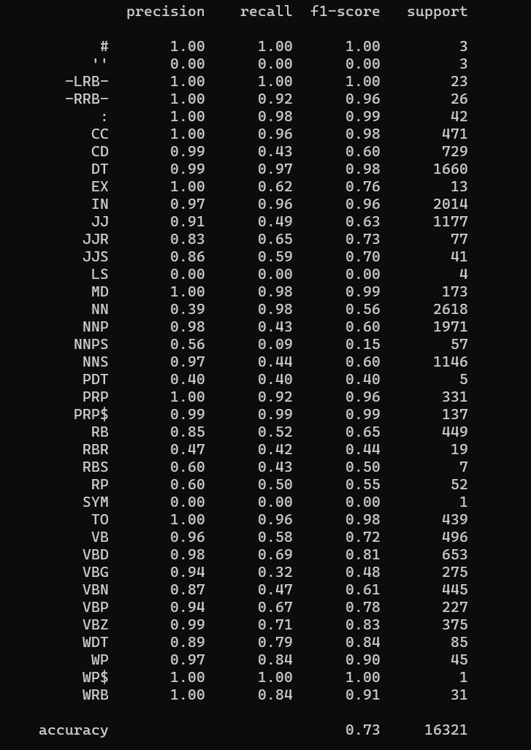

Overal accuracy for 36 pos tags is 73%

2. Results using 4 POS tags.

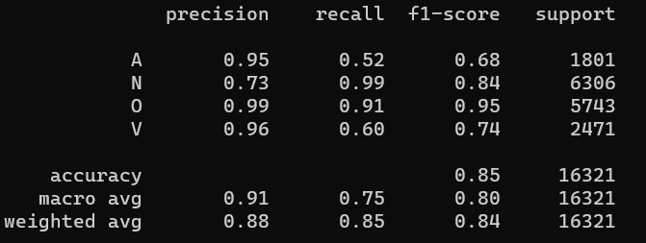

Overall Accuracy using 4 POS tags is 85%

Explanation: We can see that there is a 12% improvement in POS tagging using only 4 tags as compared to 36 tags. This is because, in the four tags case we have lesser ambigious cases than the 36 tags. When the tags are more there is more chance of making an error, hence 36 tags does not perform as good as the 4 tag setting.